MATLAB CODE SIGNALS AND

SYSTEMS-2

Supreet

Febuary 1, 2019

**Objective: -**

1. Generation of different signals and exploration of different functions related to signals processing in MATLAB
2. Perform basic operations on the signals

**Requirements: -**

1. MATLAB software

**Theory: -**

A **signal** is a function that "conveys information about the behaviour or attributes of some phenomenon". A **signal** may also be defined as an "observable change in a quantifiable entity".

values of the signal to the time vector.

Some basic operations on signals that have been performed as a part of this experiment are:-

1. Even and Odd Signal One of characteristics of signal is symmetry that may be useful for signal analysis.Even signals are symmetric around vertical axis, and Odd signals are symmetric about origin.
   1. Even Signal: A signal is referred to as an even if it is identical to its time-reversed counterparts; x(t) = x(-t).
   2. Odd Signal: A signal is odd if x(t) = -x(-t). An odd signal must be 0 at t=0, in other words, odd signal passes the origin.
2. linearity describes that you can describe the effects of a system by separating the input signal into simple parts and using superposition at the output to restore the overall system output. Mathematically, we say that a system with transformation TrTr is **linear** if the following holds:

Tr{a⋅x1(t)+b⋅x2(t)}=a⋅Tr{x1(t)}+b⋅Tr{x2(t)}.

**CODE:-**

1. Unit impulse function δ(t):

function x5=impls1(tt)  
 for i=1:length(tt)  
 if(tt(i)==0)  
 x5(i)=1;  
 else  
 x5(i)=0;  
 end  
 end  
end

Error using imp1 (line 2)  
Not enough input arguments.

[*Published with MATLAB® R2014a*](http://www.mathworks.com/products/matlab)

1. Unit step function u(t):

function xe=step1(tt)  
 for i=1:length(tt)  
 if(tt(i)>=0)  
 xe(i)=1;  
 else  
 xe(i)=0;  
 end  
 end  
 end

Error using step1 (line 2)  
Not enough input arguments.

[*Published with MATLAB® R2014a*](http://www.mathworks.com/products/matlab)

1. Ramp function r(t) :

function xa=ramp1(tt)  
 for i=1:length(tt)  
 if(tt(i)>=0)  
 xa(i)=tt(i);  
 else  
 xa(i)=0;  
 end  
 end  
 end

Error using ramp1 (line 2)  
Not enough input arguments.

[*Published with MATLAB® R2014a*](http://www.mathworks.com/products/matlab)

1. u(t)+r(t-2):

function xa=ramp_step(tt)  
 for i=1:length(tt)  
 if(tt(i)>=2)  
 xa(i)=tt(i)+1;  
 elseif(tt(i)>=0)  
 xa(i)=1;  
 else  
 xa(i)=0;  
 end  
 end  
 end

Error using ramp_step (line 2)  
Not enough input arguments.

[*Published with MATLAB® R2014a*](http://www.mathworks.com/products/matlab)

$\int{\begin{aligned}u\left(t\right) dt: \\ \end{aligned}}$

function xe=step1(tt)  
 for i=1:length(tt)  
 if(tt(i)>=0)  
 xe(i)=1*tt(i);  
 else  
 xe(i)=0;  
 end  
 end  
 end

Error using step_int (line 2)  
Not enough input arguments.

[*Published with MATLAB® R2014a*](http://www.mathworks.com/products/matlab)

1. Unit parabola function p(t):

function xa=para1(tt)  
 for i=1:length(tt)  
 xa(i)=4*(tt(i)).^2;  
 end  
 end

Error using para1 (line 2)  
Not enough input arguments.

[*Published with MATLAB® R2014a*](http://www.mathworks.com/products/matlab)

1. Signum function sgn(t):

function x5=sgn1(tt)  
 for i=1:length(tt)  
 if(tt(i)<0)  
 x5(i)= -1;  
 elseif(tt(i)==0)  
 x5(i) = 0;  
 else  
 x5(i) = 1;  
  
  
 end  
end

Error using sgn1 (line 2)  
Not enough input arguments.

[*Published with MATLAB® R2014a*](http://www.mathworks.com/products/matlab)

1. Sinc(t):

function xa=sinc1(tt)  
 for i=1:length(tt)  
 xa(i)=sin(i)/tt(i);  
 end  
 end

Error using sinc1 (line 2)  
Not enough input arguments.

[*Published with MATLAB® R2014a*](http://www.mathworks.com/products/matlab)

1. Display of graph for all functions:

clc;  
t = 0:0.01:20;  
t1 = -20:0.01:20;  
  
x1 = imp1(t1);  
subplot(3,3,1)  
plot(t1,x1,'y');  
xlabel('Time (sec)');  
ylabel('Amplitude') ;  
title('imp');  
x2 = step1(t);  
subplot(3,3,2);  
plot(t,x2);  
xlabel('Time (sec)');  
ylabel('Amplitude') ;  
title('step');  
x3 = ramp1(t);  
subplot(3,3,3);  
plot(t,x3)  
xlabel('Time (sec)');  
ylabel('Amplitude') ;  
title('ramp');  
  
  
x4 = ramp_step(t1);  
subplot(3,3,4);  
plot(t1,x4)  
xlabel('Time (sec)');  
ylabel('Amplitude') ;  
title('u(t)+r(t-2)');  
  
x5 = step_int(t);  
subplot(3,3,5);  
plot(t,x5)  
xlabel('Time (sec)');  
ylabel('Amplitude') ;  
title('unit impulse integral');  
  
  
x6 = para1(t1);  
subplot(3,3,6);  
plot(t1,x6)  
xlabel('Time (sec)');  
ylabel('Amplitude') ;  
title('unit para');  
x7 = sgn1(t1);  
subplot(3,3,7);  
plot(t1,x7);  
xlabel('Time (sec)');  
ylabel('Amplitude') ;  
title('signum');  
x8 = sinc1(t1);  
subplot(3,3,8);  
plot(t1,x8);  
xlabel('Time (sec)');  
ylabel('Amplitude') ;  
title('sinc');

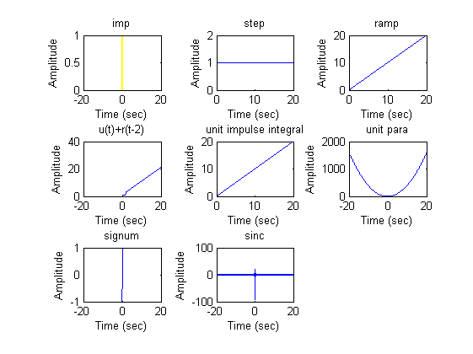

[*Published with MATLAB® R2014a*](http://www.mathworks.com/products/matlab)

**Even and odd functions:**

1. Odd function:

function xa=odd1(tt)  
l = length(tt);  
 for i=1:length(tt)  
 xa(i)=(tt(i)-tt(l-i+1))/2;  
 end  
 end

Error using odd1 (line 2)  
Not enough input arguments.

[*Published with MATLAB® R2014a*](http://www.mathworks.com/products/matlab)

1. Even function :

function xa=even1(tt)  
l = length(tt);  
 for i=1:length(tt)  
 xa(i)=(tt(i)+tt(l-i+1))/2;  
 end  
 end

Error using even1 (line 2)  
Not enough input arguments.

[*Published with MATLAB® R2014a*](http://www.mathworks.com/products/matlab)

1. Plot of signal’s even and odd parts:

t = -20: 0.1:20;  
figure('Name','e^(jt)');  
fun_x1 = @(x) exp(1i*x);  
x1 = fun_x1(t);  
odd_x1 = odd1(x1/1i);  
even_x1 = even1(x1);  
subplot(2,2,1)  
plot(t,even_x1);  
xlabel('Time (sec)');  
ylabel('Amplitude') ;  
title('even');  
subplot(2,2,2)  
plot(t,odd_x1);  
xlabel('Time (sec)');  
ylabel('Amplitude') ;  
title('odd');  
  
figure('Name','1+2t+3t^2+4t^5');  
%fun_x2 = @(x) (1+2*x+3*x*x+4*x^5);  
x2 = (1+2.*t+3.*t.*t+4.*t.^5);  
odd_x2 = odd1(x2);  
even_x2 = even1(x2);  
subplot(2,2,1)  
plot(t,even_x2);  
xlabel('Time (sec)');  
ylabel('Amplitude') ;  
title('even');  
subplot(2,2,2)  
plot(t,odd_x2);  
xlabel('Time (sec)');  
ylabel('Amplitude') ;  
title('odd');  
  
figure('Name','e^(-2t) cos(3t)');  
%fun_x3 = @(x) exp(-2*x)*cos(3*x);  
x3 = exp(-2*(t)).*cos(3*(t)) ;  
odd_x3 = odd1(x3);  
even_x3 = even1(x3);  
subplot(2,2,1)  
plot(t,even_x3);  
xlabel('Time (sec)');  
ylabel('Amplitude') ;  
title('even');  
subplot(2,2,2)  
plot(t,odd_x3);  
xlabel('Time (sec)');  
ylabel('Amplitude') ;  
title('odd');

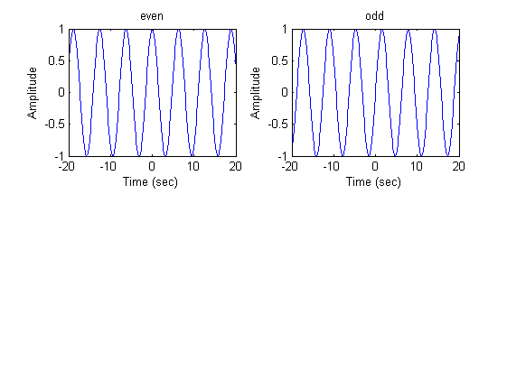

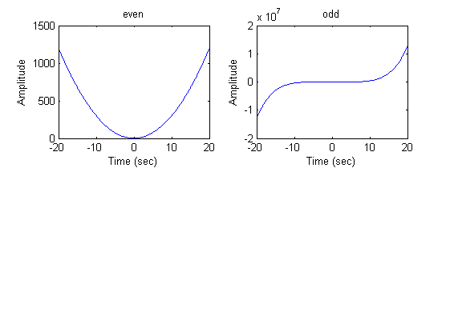

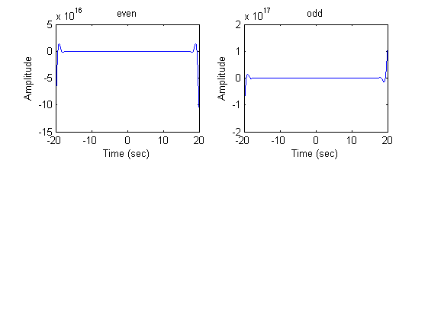

[*Published with MATLAB® R2014a*](http://www.mathworks.com/products/matlab)

1. Linearity :

The functions are

* + y(n) = nx(n)
  + y(n) = x2(n)

t = -20:0.1:20;  
%fun_x1 = @x x*cos(x);  
x1 = t.*cos(t);  
t2 = 2*t;  
x1_2 = t2.*cos(t2);  
xc = sum1(x1)+sum1(x1_2);  
x13 = sum1(t.*cos(t)+t*2.*cos(t*2));  
disp('1st system');  
if(xc == x13)  
 disp('linear');  
else  
 disp('non-linear');  
end  
  
x2 = sin(t).^2;  
%t2 = 2*t;  
x2_2 = sin(t2).^2;  
xc2 = sum1(x2)+sum1(x2_2);  
x23 = sum1(t.*cos(t)+t*2.*cos(t*2));  
disp('2nd system');  
if(xc2 == x23)  
 disp('linear');  
else  
 disp('non-linear');  
end

1st system  
non-linear  
2nd system  
non-linear

[*Published with MATLAB® R2014a*](http://www.mathworks.com/products/matlab)

1. sum1 function:

function x=sum1(tt)  
x = 0;  
 for i=1:length(tt)  
 x=x+tt(i);  
 end  
 end

Error using sum1 (line 3)  
Not enough input arguments.

[*Published with MATLAB® R2014a*](http://www.mathworks.com/products/matlab)

**OBSERVATION:-**

**All the graphs have been displayed and parameters are verified.**

**CONCLUSION:-**

**All operations in different signals were executed.**